**Lab 7. Marine Mesozoic Reptiles**

**Background:** Look at **Figure 1**, the phylogenetic tree above by Abby Howard. You can see that distantly-related reptilian groups have repeatedly re-invaded the aquatic realm. Three separate invasions led to the evolution of large marine carnivores- **Icthyosaurs, Sauropterygians and Mosasaurs**. You will be looking at representatives of these groups. In some groups clear evidence of their terrestrial origins may be seen in the limb structures. In others the limbs have become greatly modified to give greater propulsive power in the water. However, all forms show evidence of their terrestrial heritage in that all of them clearly breathed air through **nares** in their skulls. None of these groups are dinosaurs.

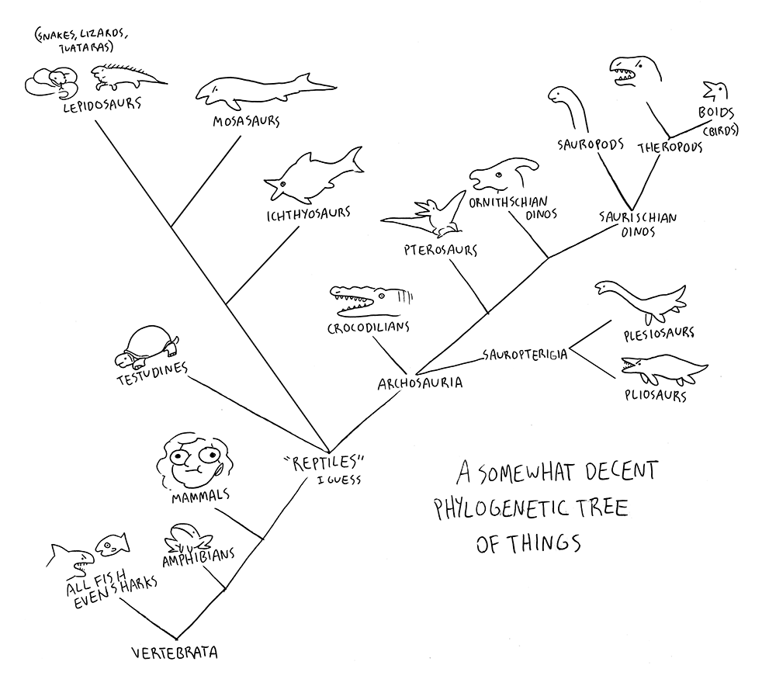

Figure 1. Artist Abby H Howard's vertebrate phylogeny

A note on terminology: The terms **proximal** and **distal** may be used to refer to the ends of bones which are nearest and furthest from the center of the body respectively.

Figure 2. Position of bones of a whale flipper and three other mammal limbs. These structures are the same for all amniotes.

**Diapsids, archosaurs: Nothosaurs**

Nothosaurs are entirely Triassic an age. Their descendnats go on to become the much more famous and fully aquatic plesiosaurs and pliosaurs. The joint surfaces where the limbs meet the pelvis and shoulder girdles are poorly ossified in the nothosaurs. They were mostly cartilage in life and would probably not have been able to support the body for extended periods of locomotion on land.

**A1. *Pachypleurosaurus*.** A nothosaur from the Middle Triassic of northern Italy. This is not a particularly well made cast; much of the fine morphological detail is hard to discern.

1. [1 point] What is the bone labeled [1]?
2. [1 point] How can you tell the top of the animal is facing you, not the underside?
3. [1 point] Are the front legs stouter than the back legs?
4. [1 point] Is this a primitive characteristic inherited from its terrestrial ancestors or a novel new characteristic?

# **Sauropterygians**

This was the longest-lived lineage of the extinct marine reptiles. They showed a huge variety in form and function, from the turtle-like placodonts of the Triassic to the long-necked fish-eating elasmosaurs of the late Cretaceous. This group includes **Plesiosaurs** and **Pliosaurs** two major lineages differentiated by the length of the neck and relative size of the skull. The latin name for the group means “lizard wings”, a reference to the large, winglike paddles the limbs evolved into. These were used to “fly” through the water in a way no other vertebrate has moved.

Figure 3. (A) Plesiosaur and (B) Pliosaur skeletons from O'Keefe (2002)

**B1:** The Loch Ness monster is supposed to be one of these animals. They are thought to have been derived from nothosaurs. The first plesiosaurs appear in the latest Triassic, and they persisted until the end of the Cretaceous.

1. [1 point] Is this animal a *Plesiosaurus* or *Pliosaurus*?
2. [1 point] What is the bone labeled [1]?
3. [1 point] There are a set of disk-shaped bones indicated by the [2]. What are these?
4. [1 point] The row of bones labeled [3] are the metacarpals (bones of the hand). There are many rod-shaped bones lying in columns distal to these metacarpals.
   1. What are these?
   2. What is the number of bones in the longest finger?
5. [1 point] What is the structure labeled [4]?

**B2. *Alzadasaurus***, a plesiosaur from the Cretaceous of Columbia.

1. [1 point] What is the structure labeled [1]?
2. [1 point] What is the structure labeled [2]?
3. [1 point] What is the structure labeled [3]?
4. [1 point] Notice the notch at the base of the skull in the area labeled [4]. What may this be the remnant of?

**Diapsids, non-archosaur: Icthyosaurs**

Icthyosaurs "fish-lizards" represent a separate and long-lasting group of marine reptiles. The first icthyosaurs appear in the early Triassic and they persisted until the late Cretaceous. Over this time period, they evolved a shape strongly convergent with dolphins, including fins supported by the manus and pes. If present, the dorsal fin had no bony support, just as the dorsal fin of a dolphin has no bones in it. Icthyosaur's torpedo-shaped bodies would have generated very little drag in the water, making them the speediest of today's predators.

**C1. This is a small ichthyosaur from the Jurassic of Germany.**

1. [1 point] What bone is labeled [1]?
2. [1 point] What are the bones that lie in the row labeled [2]?
3. [1 point] Why do you think that marine animals (including mammalian whales) often have extra phlanges? The typical number for the longest finger in a vertebrate is 4.
4. [1 point] Note the bend in the tail at [3]. It was first thought that this bend was just the result of fossilization, but it is now recognized that the bend was present in living ichthyosaurs, sending the spine down into the lower half of the tail fin. What sort of evidence do you think changed this view?
5. [1 point] What are the structures labeled [4]? Include the side of the body.

**C2. This is an ichthyosaur from the Early Jurassic of England.**

1. [1 point] Think about a whale’s tail vs a fish tail. Those animals swim by moving in different ways. How would you describe the way ichthyosaurs moved their tail fins relative to their spine? Think about which way would generate more force given the way the fin is oriented.
2. [1 point] Compared to a plesiosaur, the ichthyosaurs have very different proportions. Rank these structures in terms of their importance to an ichthyosaur swimming: **manus, pes, tail**.
3. [1point] Why would the large diameter of the eye suggest Icthyosaurs dove into very deep water.
4. [1 point] Give two features that suggest that **C1** and **C2** were not from the same species.

**Mosasaurs**

Mosasaurs are the last major marine reptiles to arrive in Mesozoic seas, becoming prominent only in the Cretaceous. They made up for lost time by becoming super-sized and super predators. Mosasaurs are most closely related to lizards, in particular the varanids (monitors including the Komodo Dragon, the largest living lizard).

In lizards the teeth are fused to the inside of the jaws. However, in mosasaurs the teeth are set in sockets, just as in archosaurs (remember lizards are not archosaurs). So here we have an example of parallel (or **convergent**) evolution. The skull has a number of unique adaptations for feeding and stronger bites.

**D1. Tylosaurus skull**

1. [1 point] Did mosasaurs have a kinetic or akinetic skull?

Tylosaurus Sketchfab on Bruin Learn (<https://sketchfab.com/3d-models/fossils-of-mosasaurus-skull-e1c2a80e42aa4ba0848ef5c308673707?utm_medium=embed&utm_campaign=share-popup&utm_content=e1c2a80e42aa4ba0848ef5c308673707>)

1. [1 point] Look at the roof of the mouth near the orbits. What unusual feature do you see?
2. [1 point] Based on the feature above, do you think this animal ate soft prey like squid or hard, shelled prey like ammonites? Why?

**D2. *Clidastes velox***. Here are two parts of the lower jaw. The intramandibular joint lay between the two pieces. One part of the jaw is labeled [1]. You may use Figure 4 below for reference.

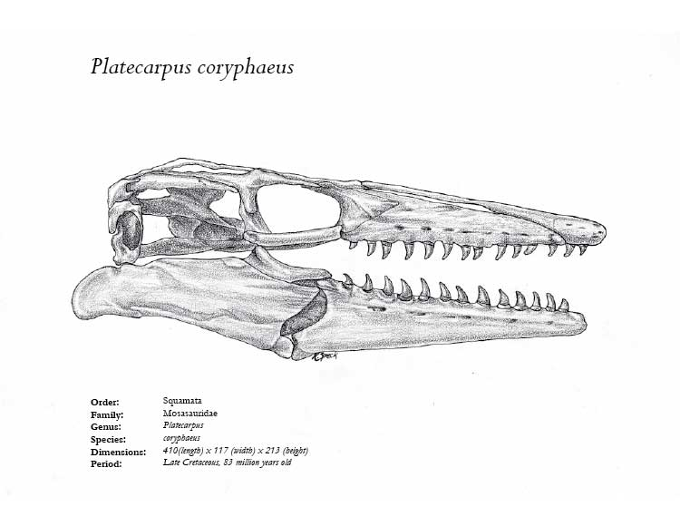

**Intramandibular joint**

**Jaw joint**

Figure 4. Platecarpus corophaeus (mosasaur) skull.

1. [1 point] There is a depression labeled [A] on [D2]. What was it for (you might want to refer to the figure above)?
2. [1 point] The pieces of the jaw meet at the orange/red patches drawn on the specimens. Note that when you try to place the jaw elements together that piece is missing. Did the side of the jaw labeled [B] face the inside or outside of the mouth?